Liceo Andrés Bello
English Department
Mr. Díaz – Mr. Vizcarro

Self-Learning Worksheet
Year 8B – English
Unit 1 – Information and Technology.

Objective | - Recognise vocabulary about technology and mass media  - Describe events using past simple about technology topics  - Apply knowledge of vocabulary in context  - Develop listening comprehension according to vocabulary related to countries and nationalities.
Abilities | - Recognise, Remember, Apply, Organise, Develop
Instructions | This is a study handbook for you, so according to the information given down here. Read it and study. Each explanation will be given as it is a class. At the end of the worksheet there are exercises about each topic worked. Each detail will be underlined. Send the worksheet to: sergiodiazcif@gmail.com  Edit the name of the document with your name and class  Example: Liam_Petterson_7A
Name
Class | Year 8 B
Score/ Mark | /29 points | 15 % of the Final Mark of this Unit
Deadline | Before April 30th

Stories about how teenagers live in a world of technology
Blake lives in a city called Manchester, which is one of the rainiest cities in the UK. He goes to the cinema, to the supermarket (Tesco), and to the computer store, where he is a premium member. He works in a company as a publicist, so most of the time he is front of a computer and on his phone, making calls for new customers. What he likes the most about his job is that he is a constant contact with technology, so he knows the updates of new apps and programmes for working. | Cathrin lives in King’s Lynn, England. Her life is quite moving as she works in a hospital, so she is busy most of the time. She is in charge of all the intensive care unit which allows her to work and manage lots of machines for her job. Sometimes, her duty is not only looking after patients but giving some lectures about the management and usage of new technologies of intensive care at the University. According to her, the new advances in healthcare are all connected to technology.

Technology
In today’s world, we move ourselves around technology wherever we are. Daily routine is full of technology, from the moment you wake up in the morning thanked the alarm clock of your phone or a digital one, going through a shower which works with technological systems of heating water up, breakfast or even when you go to school. Every time at any moment we use all types of technological devices. The question is: Can we live without technology?
As human beings, we try to innovate and change the world with the advantages that life is giving us. Now, the degree of computerization have achieved aspects to consider for the population to get their life more simplified and with complete access to all type of information.
For example: Internet, Music, News, Television, Apps, Fashion and others segments in our world.
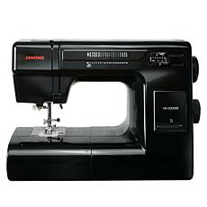
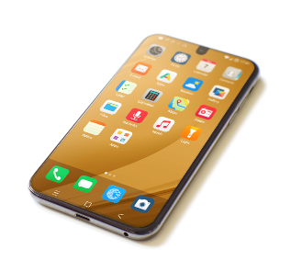
What about inventions?
In the past, the technological inventions were considered not as fashionable as today, why? Some people thought these inventors were crazy, for instance, during the industrial revolution in the USA, drilling machine, sewing machine and telephone were invented. Inventions that nowadays we use in our daily life.
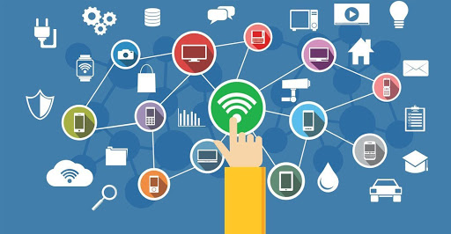
THE INTERNET
It is the device and tool for connecting people around the globe. Communication is important, so it is the information centre and assistant for everyone.

Watch video clips and download music
What can we do on internet?
Surf the internet
Chat with Friends
Install programmes and create apps
Play video games

Send and read e-mails

Note: There are also things that are not allowed to do on the web, like scamming, cyberbully, cybercrime, visiting prohibited sites or +18.

Time to work!
(5 points – 0.5 each)
(9 points)

(9 points)
According to the previous activity. Choose four sentences and answer the question…
What would you? (4 points)
- ____________________________________________________________________
- ____________________________________________________________________
- ____________________________________________________________________
- ____________________________________________________________________

Item. 3 – Listen to the following song and read the lyrics, can you tell me how this song is connected to technology? Why? (2 points)
________________________________________________________________________________________________________________________________________________________________________________________________________________________________________________________________________________________________________________________________________________________________________
Song: Ben Dolic – Violent Thing https://www.youtube.com/watch?v=COx0pTCv7Bg

