Liceo Andrés Bello

English Department

Mr. Díaz – Mr. Vizcarro

**Self-Learning Worksheet**

**Year 7A – English**

**Unit 1 – Feelings and Opinions – Facial Features around the Globe.**

|  |  |  |
| --- | --- | --- |
| Objective | * Recognise vocabulary about facial features. * Apply basic opinion phrases using vocabulary related to facial expression/features. * Develop Listening comprehension according to the topics exposed by giving information | |
| Abilities | * Recognise, Remember, Apply, Organise, Develop | |
| Instructions | This is a study handbook for you, so according to the information given down here. Read it and study. Each explanation will be given as it is a class. At the end of the worksheet there are exercises about each topic worked. Each detail will be underlined. Send the worksheet to: [sergiodiazcif@gmail.com](mailto:sergiodiazcif@gmail.com)  ***Edit the name of the document with your name and class***  ***Example: Liam_Petterson_7A*** | |
| Name |  | |
| Class | Year 7 A | |
| Score/ Mark | /27 points 🡪 | 15 % of the Final Mark of this Unit |
| Deadline | Before April 30th | |

**Face Features.**

Each person in the world has different face characteristics that make them special for some reasons. In the world, there exist millions of people with a unique detail in their faces. For example, some people would say if you are **blonde,** you are not Chilean or if you are **dark-skinned** you are from a place where sunny days are every day. But, only **hair colour** and skin defines you? No, of course not, also personalities!

Let’s talk about Faces!

There are different **sizes, shapes and colour** in terms of **facial expressions.** **Square or rounded faces**, **long and** **big ones**, and in terms of colours you got **pale, pink and dark-skinned**. As well in eyes, you can have **brown, green, blue, or hazel eyes.**

Let’s review some parts of the face as well, a person has: **Cheeks, mouth (lips), chin, jaw, teeth, nose, eyes, eyebrows, eyelashes, ears, forehead and hair.**

Now, there also some other details in a person’s face we have to consider, for example if their **eyelashes** are short or long, or prominent **eyebrows**. These ones can also be thin as well. This person can have a **beard or moustache** if it is a guy, or any person can wear **glasses** and **piercings** as accessories.

Look at this picture as an example

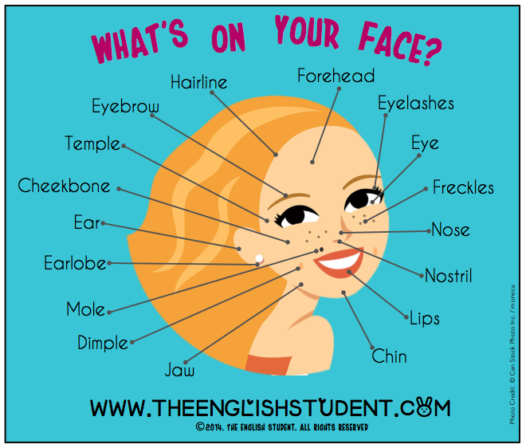

In this picture you can see different parts of what on someone’s face. In this case, this girl has other details about her face.

Does she look happy? She does! However, this feature is related to her personality.

**Hair colour and style.**

According to scientists, the hair colour varies from the geographical zone you are and biological genes you have. The colour of your hair can change through the years and also you can **dye** it for making it more fashionable.

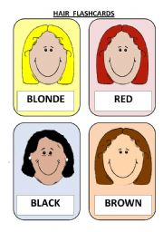

In this picture, there are four major hair colours that are **Blonde, Red, Black** and **Brown.** But, as it was said before, there also other colours you can use for looking more stylish.

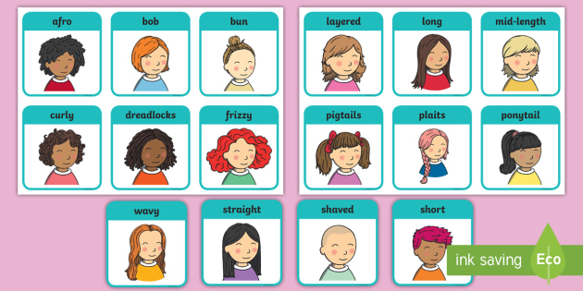Now, about the styles, you got these ones.



You see, many people can wear their hair the way they want. Do you like them? I do, actually. For example, ***my hair is short and straight and its colour is black.***

**TIME TO WORK!**

According to what was explained about facial expression, how to give an opinion and difference between countries in terms of faces, complete the following activities.

1. **Item 1 (9 points)**

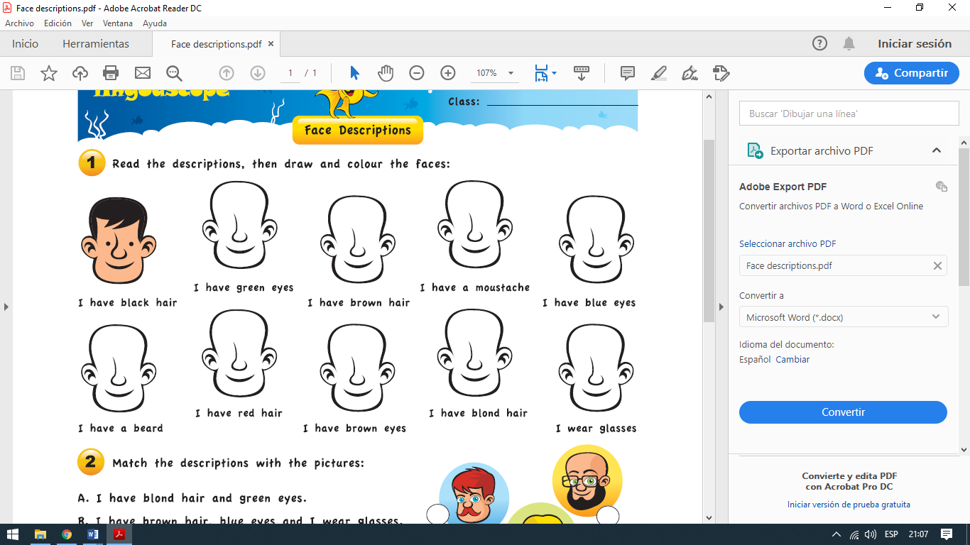

1. 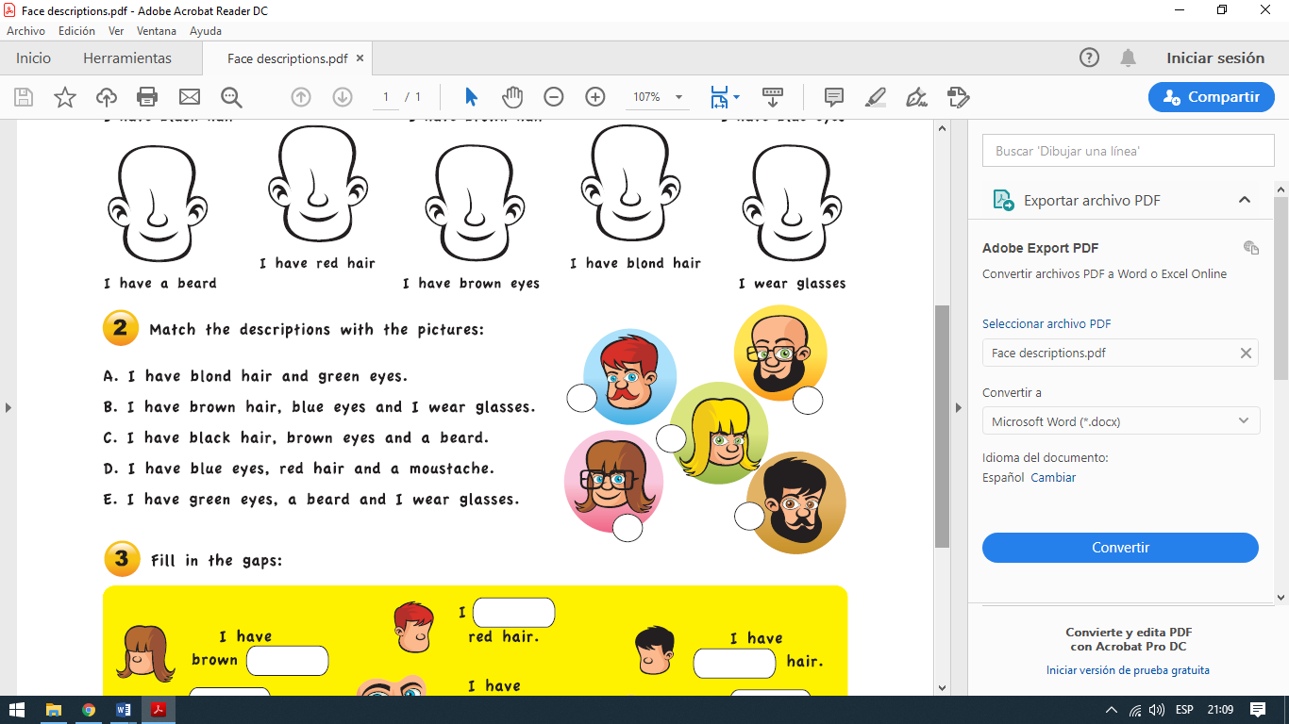**Item 2. (5 points)**

**Item 3. (5 points- 0.5 each points)**

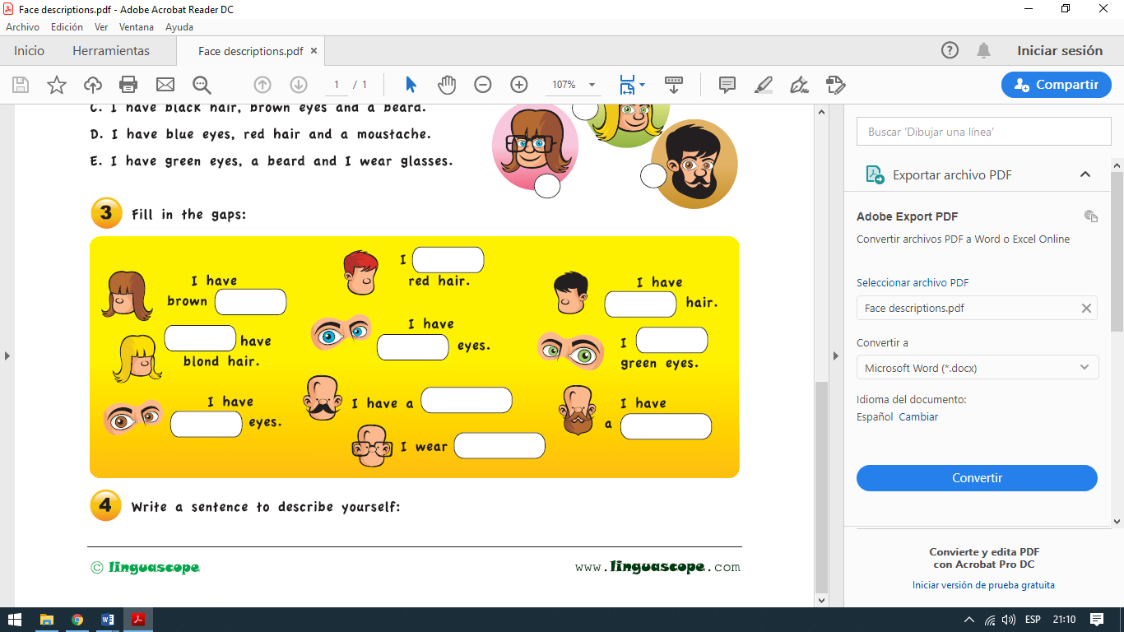

**Item 4 – (2 points)**

**Item 5. Listen to this song and answer the following question. The song is on Youtube or Spotify.**

Rasmusenn – Higher Ground: <https://www.youtube.com/watch?v=JilMmML1E18>

1. Listen to the song and read the lyrics on it, try to PICTURE** the face of the person singing. Colour it and point out his facial expression. Set 6 characteristics of his face. **(6 points)**

**The drawing, you can make it separately in a piece of paper, take a photo of it and attach in the box below.**

*\*\* PICTURE is to blow your imagination on how this person could look like.*

|  |
| --- |
|  |