|  |  |  |  |  |
| --- | --- | --- | --- | --- |
| **Handout n° 1**: “Jobs and occupations“ | | | **Score** |  |
| **Name:** | **Grade: 1** °C | **Date:** | **mark:** | |
| **Final Score: 47 required % :** (4.0 with 28 points) | | |
| **Objetivo(s) de Evaluación:**   * To identify specific vocabulary related to jobs and occupations. * To recognize specific information in a text (scanning) * To write simple sentences describing workers. | | | | |
| **Instruccions:**   * This is a self-learning handout. * You can use videos, capsules, ppts from the English website. <https://jvizcarro.wixsite.com/ingleslab> * You can use unformation from internet, but be careful in the way you use it. Remember that copy from this source or a classmate is considered plagiarism, and you will get the lowest mark. * If you have any doubt, you can ask me at e-mail: [jaumevizcarroalvarez@gmail.com](mailto:jaumevizcarroalvarez@gmail.com) from Monday to Friday between 10:00 a las 14:00 y 15:00 a las 17:00. * Deadline: 30th April, 2020 - 17:00 hrs. * The name of the archive must indicate the following: “**name_surname_grade**”, example: **pedro_contreras_1C** | | | | |

1. **According to the contents work in the first lesson, match concepts from column A writing the letter in the corresponding gap from column B. (10 points)**

|  |  |
| --- | --- |
| **COLUMN A** | **COLUMN B** |
| 1. **Business card** 2. **Skill** 3. **Quality** 4. **Employ** 5. **Headhunter** 6. **To be keen on** 7. **Marketing** 8. **Suitable** 9. **Courier** 10. **application** | **___ apropiado**  **___postulación**  **___targeta de presentación**  **___ calidad**  **___ ser Bueno para**  **___ reclutador**  **___mensajero**  **___ mercadotecnia**  **___habilidad**  **___ contratar** |

**Read the advertisements below and then answer the post-reading questions**

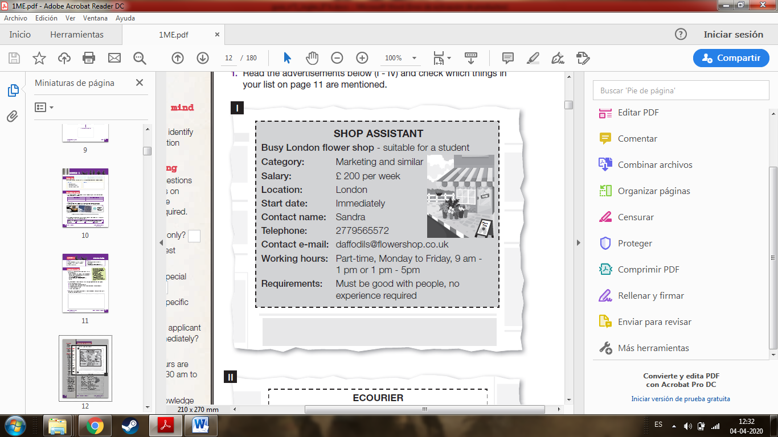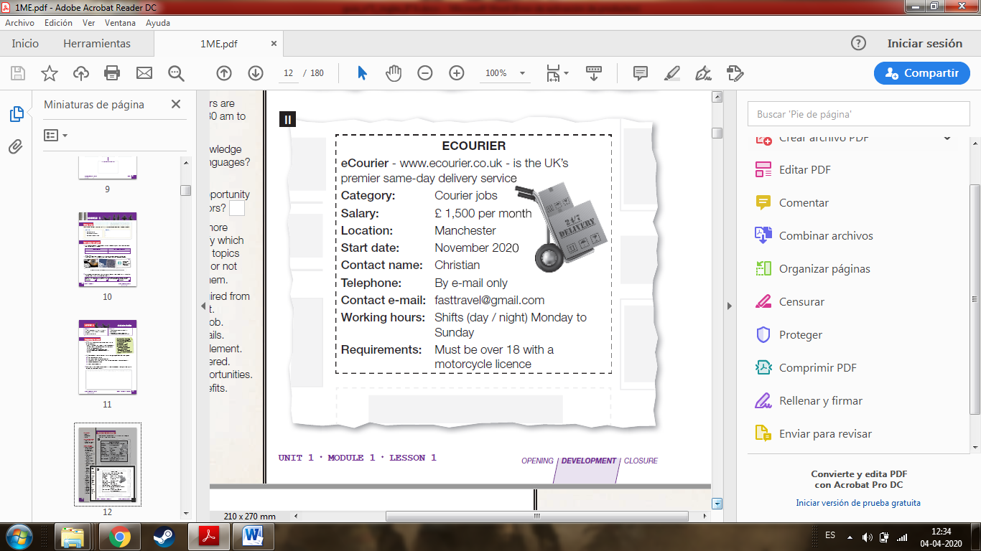

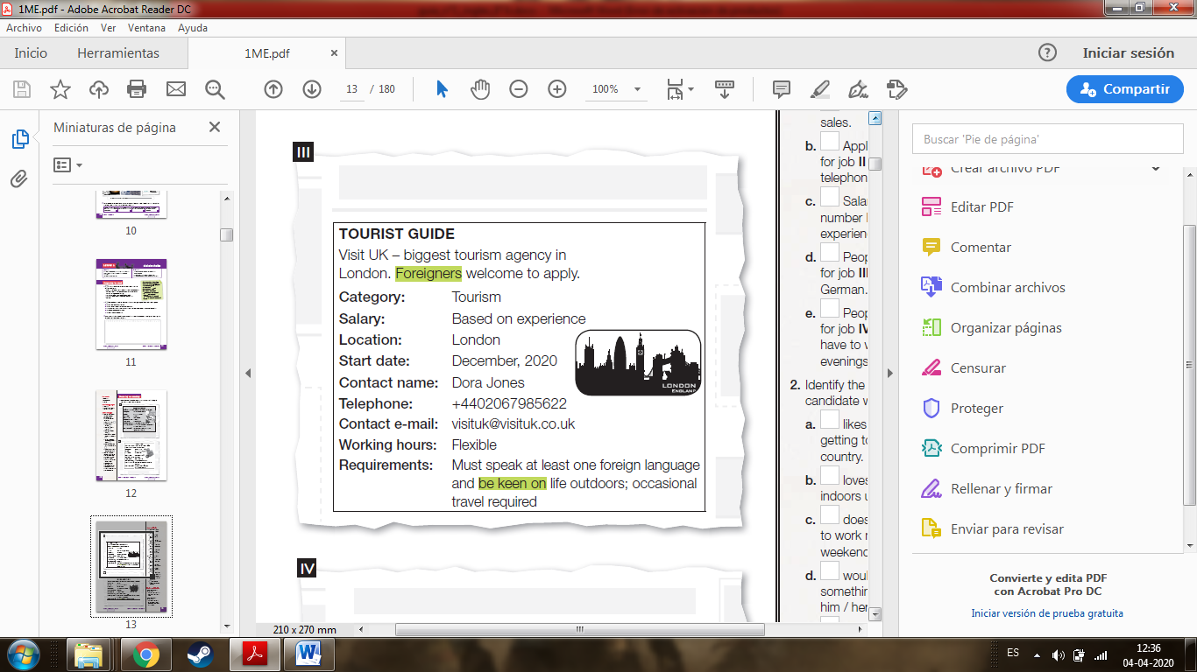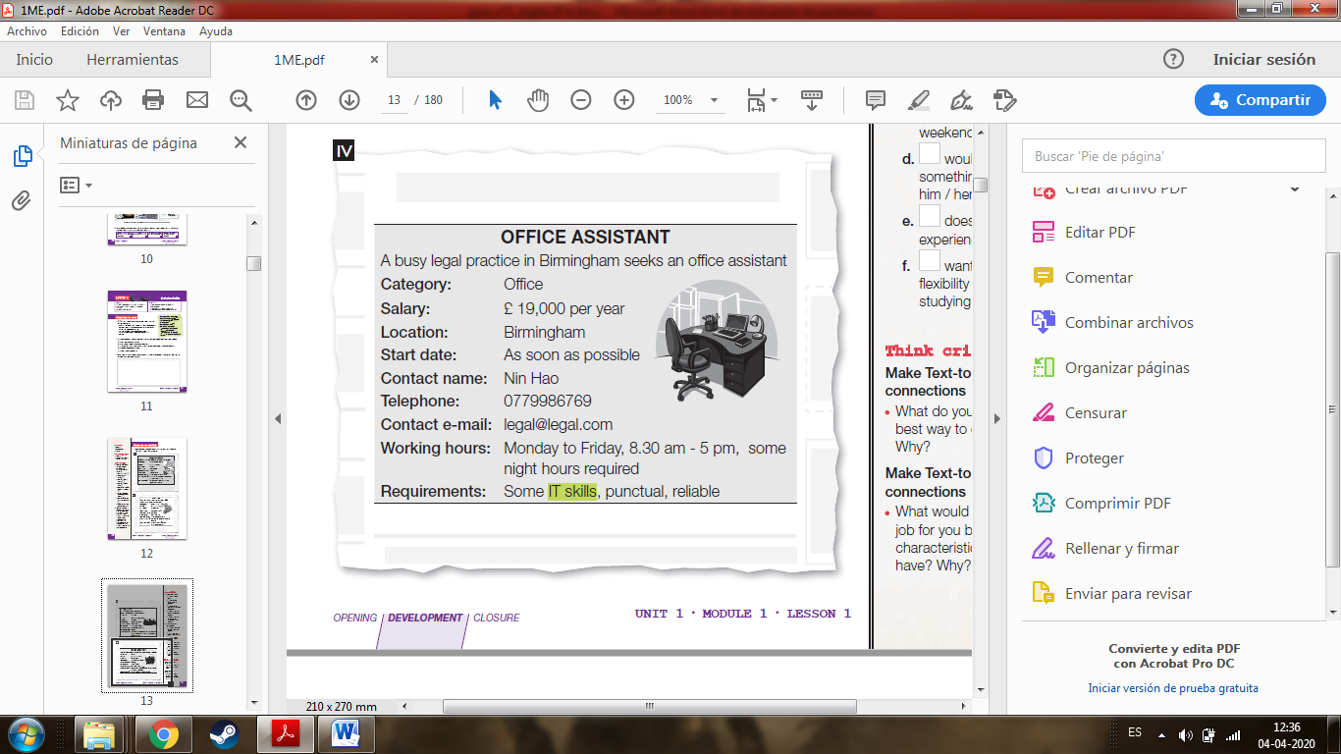

**2) Read these questions and then focus on finding only the information required. Write the number of the in the gap. (8points)**

a. Which job is part-time only? Text n° _____

b. Which job offers the best salary? Text n° _____

c. Which job requires a special license? Text n° _____

d. Which job requires a specific age? Text n° _____

e. Which job requires the applicant to start immediately? Text n° _____

f. Which job working hours are generally 8.30 am to 5 pm? Text n° _____

g. Which job requires knowledge of foreign languages? Text n° _____

h. offers the opportunity to be outdoors? Text n° _____

**3)True or false. Justify false answers. (7 points)**

a. ____ Job I involves sales.

b. ____ Applications for job II only by telephone

c. ____ Salary for job number III depends on experience.

d. ____ People applying for job III must speak German.

e. ____ People applying for job IV might have to work in the evenings.

**4) Identify the job for a candidate who: (6 points)**

a. likes traveling and getting to know the country. Text n°______

b. loves working indoors using IT skills. Text n°______

c. doesn’t want to work nights and weekends. Text n°______

d. would love to do something that will let him / her meet people. Text n°______

e. doesn’t have any experience. Text n°______

f. wants some flexibility to Text n°______

**5) Complete sentences below following the example. (16 points)**

|  |  |
| --- | --- |
| Baker | A person who bakes cakes and bread. |
| Driver |  |
| Astronomer |  |
| Geneticist |  |
| Hairdresser |  |
| Reporter |  |
| Archeologist |  |
| Researcher |  |
| Actor |  |



Good luck!!

If you have doubts write to my teacher e – mail or Instagram

Mrvizcarro