|  |  |  |  |  |
| --- | --- | --- | --- | --- |
| **Handout n° 1**: “Jobs and occupations“ | | | **Score** |  |
| **Name:** | **Grade: 3** °C | **Date:** | **mark:** | |
| **Final Score: 37 required % :** (4.0 with 22 points) | | |
| **Objetivo(s) de Evaluación:**   * To identify specific vocabulary related to jobs and occupations. * To recognize specific information in a text (scanning) * To write simple sentences describing workers. | | | | |
| **Instruccions:**   * This is a self-learning handout. * You can use videos, capsules, ppts from the English website. <https://jvizcarro.wixsite.com/ingleslab> * You can use unformation from internet, but be careful in the way you use it. Remember that copy from this source or a classmate is considered plagiarism, and you will get the lowest mark. * If you have any doubt, you can ask me at e-mail: [jaumevizcarroalvarez@gmail.com](mailto:jaumevizcarroalvarez@gmail.com) from Monday to Friday between 10:00 a las 14:00 y 15:00 a las 17:00. * Deadline: 30th April, 2020 - 17:00 hrs. * The name of the archive must indicate the following: “**name_surname_grade**”, example: **pedro_contreras_1C** | | | | |

1. **The box bellow was divided in 5 working sectors. Classify jobs given in the list according to the sector they belong to. (15 points)**

|  |
| --- |
| **JOBS** |
| **Administrative assistant – bike courier – brick layer – bus driver – call center agent – civil engineer – clerk –**  **fashion designer- florist – forklift truck operator – hotel receptionist – FX makeup artist - plumber – tour guide –**  **travel agent** |

|  |  |  |  |  |
| --- | --- | --- | --- | --- |
| **Construction** | **Art and design** | **Administrative** | **Transport** | **Tourisn** |
|  |  |  |  |  |

**Read the text carefully. After that you will have to answer some questions.**

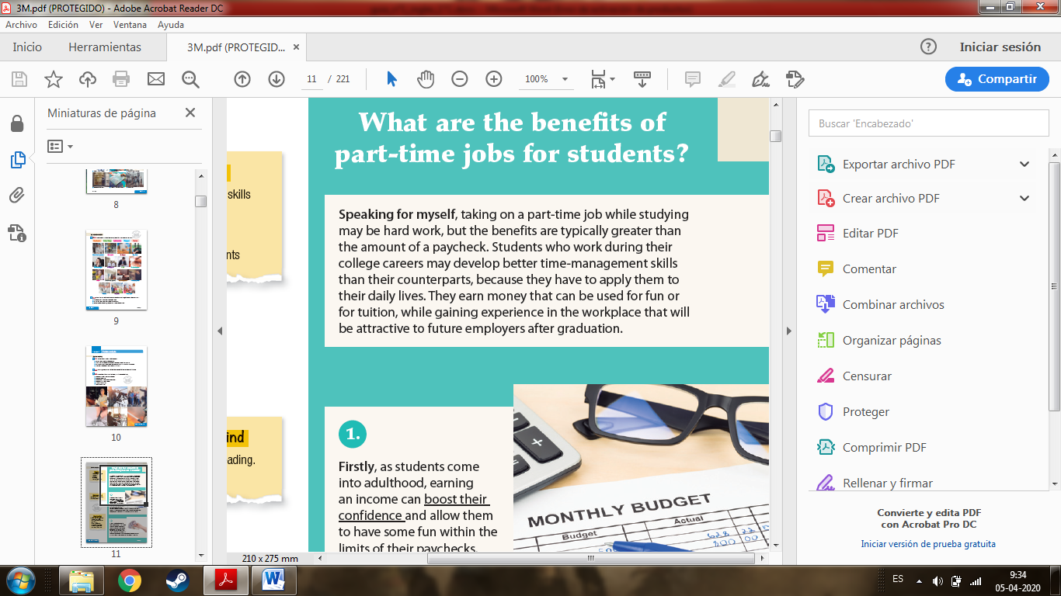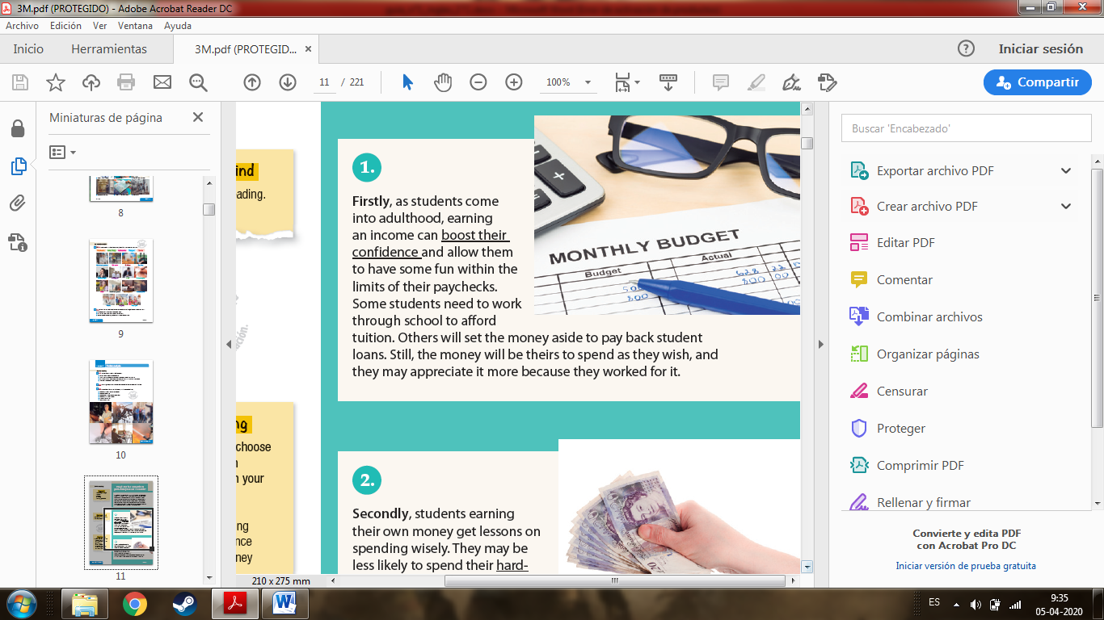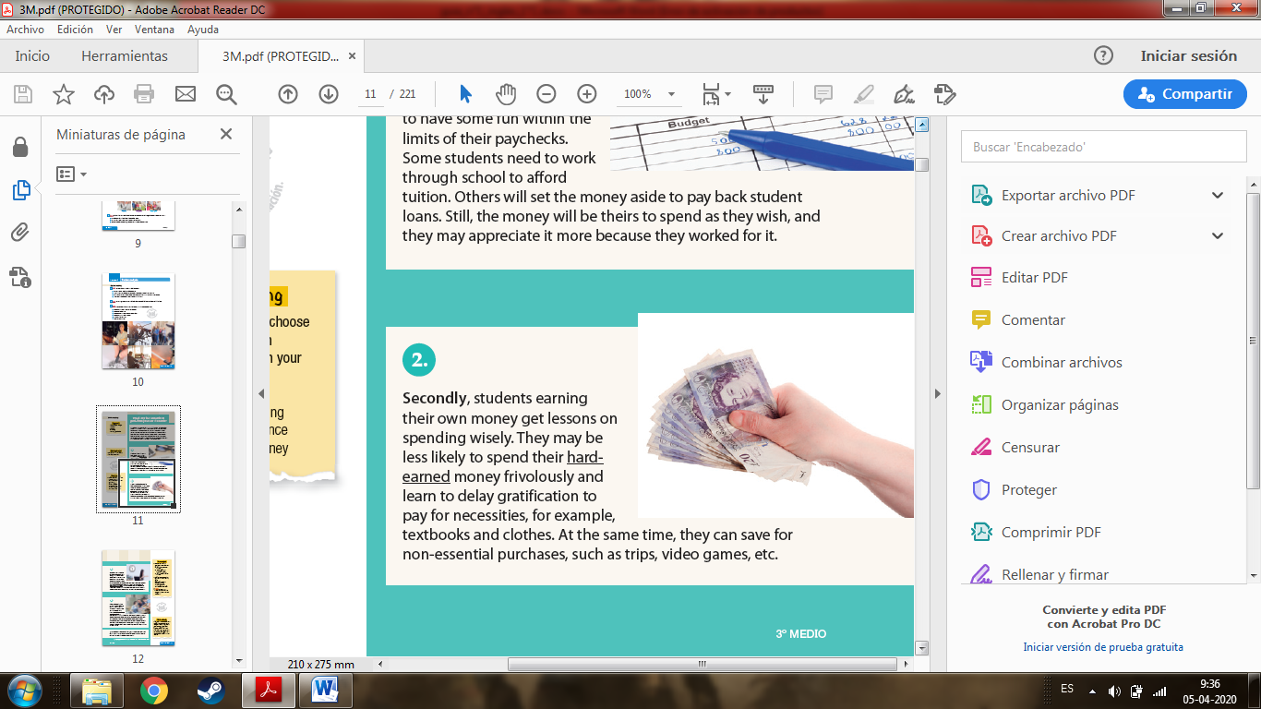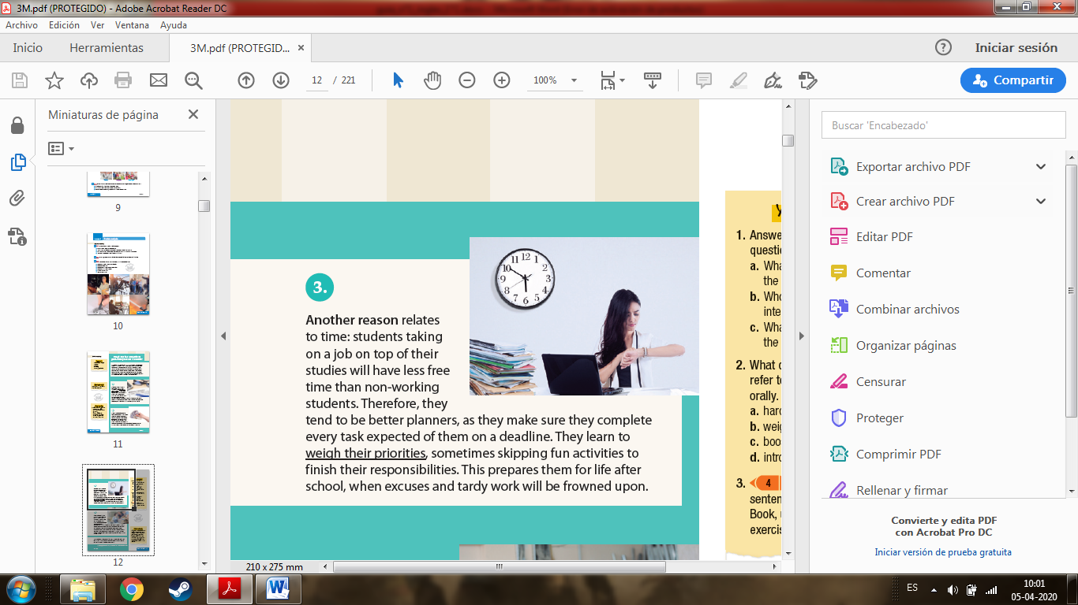

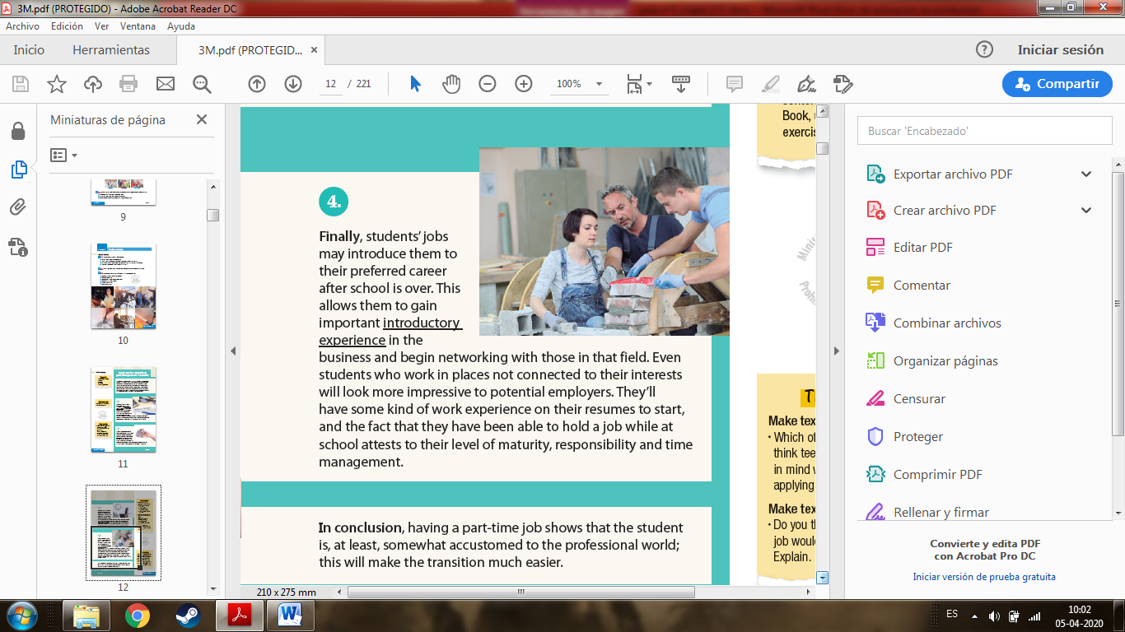

1. **Read the text again, identify the connectors in bold in the text, and indicate which one is used to: (8 points)**
2. **Start an opinion: _________________________________________**
3. **Provide reason: __________________________________________**
4. **Provide example: _________________________________________**
5. **Come to a conclusion: _____________________________________**
6. **Answer these questions: (6 points)**
7. **Why is it necessary for some student to work?**
8. **What can part-time working teenagers learn about money?**

**Drama: Now read the following scene and answer the questions at the end.**

**Characters** : Narrator, Santa Claus, Elves

**Setting** : Santa’s workshop at the North Pole

(The Elves are walking around the workshop holding placards saying ‘No pay, no work’.)

***Narrator****: This year, Santa will probably not be able to deliver all presents on time because there are some problems at the North Pole. Let’s find out what’s happening.*

**Elves** (together): No pay, no work! No pay, no work! No pay, no work!  
**Elf 1** : We, the Elves, are not happy!

**Elf 2** : In fact, we are very angry!

**Elf 3** : We are working very hard.

**Elf 4** : But we don‘t get paid.

**Elf 5** : We want a salary!

**Elf 6** : We want paid holidays!

**Elf 7** : We want to retire at 45!

**Elf 8** : We want free healthcare.

**Elf 1** : We want a company sled.

**Elf 2** : We want free lunch at work.

**Elf 3** : We want 3 months off every year.

***Narrator****: Look who’s coming in. It’s Santa. Let’s see what he has to say about this.*

**Santa**: Ho, ho, ho! What’s going on here? Why aren’t you working?

**Elf 4** : We want to get paid, Santa.

**Elf 5** : And we want a Christmas bonus.

**Elf 6** : And free ice cream.

**Santa** : Wait a minute. I’m Santa. You’re working for Santa and I don’t charge children for the presents they get. Where would I get money to pay you? I don’t make any profit.

**Elves** (together): No pay, no work! No pay, no work! No pay, no work!

**Santa** : Okay, okay, enough. I’ll see what I can do. Maybe we can start charging for presents.

**Elf 7** : We’ll make a profit.

**Elf 8** : You can pay us a big bonus.

**Elf 1** : And with the rest of the money we’ll go on a trip to Jamaica.

**Elves** (together): Hoorah! **Santa** : Wait a minute. What if children don’t have any money?

**Elf 2** : We’ll take their parents’ credit cards.

**Elf 3** : Or the children’s piggy banks.

**Elf 4** : We could give them credit.

**Elf 5** : And charge high lending fees.

**Elf 6** : We’ll become a Santa Superstore.

**Elf 7** : Or a Santa-E-bay where you can pay with SantaPal.

**Elf 8** : We’ll make lots of money.

**Santa** : Well, I have to say it sounds good. And I’ve never been on holiday to Jamaica. Okay, let’s do it!

**Elves** (together): Hoorah, hoorah! Happy Christmas everybody!

**Answer these questions (2 points each)**

1. What elements of drama do you see in the script?
2. What types of characters are present in the scene?
3. What elements are giving the atmosphere?
4. What type of scene is this one?