Handout n° 3: “Used to“ |  |  | Score
Name: | Grade: 1 °C | Date: | mark:  --------------------
--------------------------------------------------------------------------------------------
Objetivo(s) de Evaluación:
- To recognize vocabulary related to jobs. (understand)
- To identify vocabulary related to “describing past habits” (understand)
- To choose the right concept according to the context (understand)

Instructions:
- This is a self-learning handout.
- You can use unformation from internet, but be careful in the way you use it. Remember that copy from this source or a classmate is considered plagiarism, and you will get the lowest mark.
- If you have any doubt, you can ask me at e-mail: jaumevizcarroalvarez@gmail.com from Monday to Friday between 10:00 - 14:00 and 15:00 - 17:00.
- Deadline: 29th June, 2020 - 17:00 hrs.
- The name of the ARCHIVE must indicate the following: “name_surname_grade”, example: pedro_contreras_1C

- Look at the pictures, and then write sentences with “used to” and “jobs” vocabulary, follow the example. (jobs vocabulary: wizard, pilot, chef, fisherman, farmer, boxer, veterinarian, manager, hunter, teacher, doctor, thief, bus driver, hairdresser, waiter, fireman, postman, engineer, policeman, stewardess, cooker, housewife)

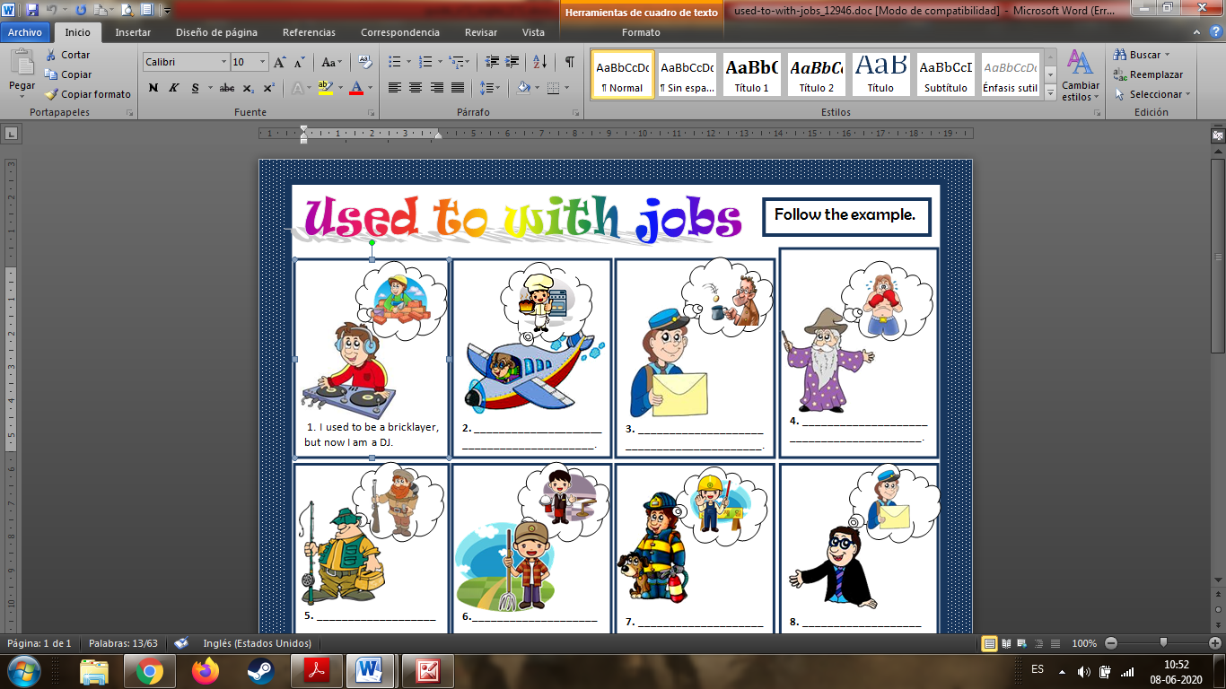
- I used to be a bricklayer, but now I am a DJ.
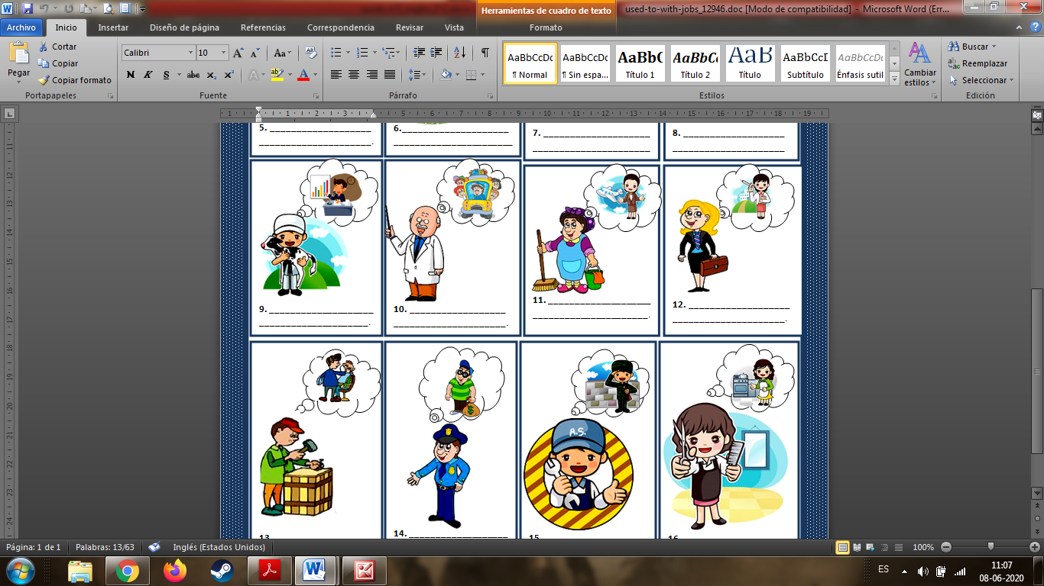

- Match the beginning of each sentence with the correct ending.

- I used to go to school here … | - ____ until computer games became popular.
- I never used to get up on time …  - This used to be a small town …  - I didn’t use to understand Maths …  - Children used to play outdoors much more …  - I didn’t use to eat many sweets …  - I used to live in the countryside … | - ____ until I gave up smoking.  - ____ when I was young in the 1950s.  - ____ until I bought an alarm clock.  - ____ before I moved to New York.  - ____ before oil was discovered here.  - ____ when I was at school; we had a terrible  teacher.

- Complete with “used to” or “didn´t use to” and a verb from de list: be (x2), have, like, speak, wear (x2), work. Follow the example.

- Sheila _used to have_ blue hair. Now it’s her natural colour.
- I ________________________ glasses. Now I wear them all the time.
- My brother ________________________ an earring. He doesn’t anymore.
- Nicole Kidman and Tom Cruise ___________________ married. They divorced in 2001.
- My father ________________________ in a bank. He worked there for two years.
- My brother _______________________ English. Now he is fluent.
- My sister _________________________ the Spice Girls. Now she prefers Alicia Keys.
- E-mail ____________________________ very common. Now everybody uses it.

